**Section 14 done: 23/23 Redux**  
**Introduction**  
* This is a core module in this course.  
* Redux is a standalone third-party library - to make state management easier because that can be hard in more complex projects.  
=> We already saw that in our course project - there we already had some cases - like where we have to pass data around through query params where state management became unnecessarily difficult.  
**Understanding State**  
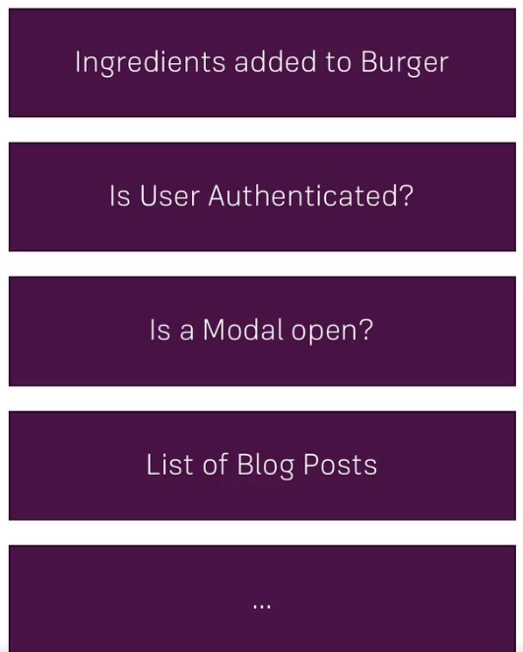  
* For example the ingredients for our Burger - the information which ingredients we added is crucial because it determines what we need to render to the screen, how should our burger preview look like there, it’s also important behind the scenes when we store that burger on a server and we need to submit all the ingredients in the HTTP Request.  
* Another example would be whether the user is authenticated or not. That can be super important as it might determine the options we’re showing in the menu or the access we’re granting to certain components.  
* Also interesting is UI State - like: is a given Modal open, is a Backdrop open, should it be open, that’s super important too, it’s less about data like ingredients and user authentication is - it’s more about our pure UI-only State, it might only be relevant to 1 single component, still this is also an example for state, more of a local than an application-wide state but still state determining what should get rendered to the screen.  
* And that is in its core what you can boil it down to.  
* State influences what you see on the screen.  
* So therefore our last example is a list of blog posts which we render, which you might filter or you might need to know which of these posts were created by the user.  
* Now what’s so complex about state? Why do we need an extra library to manage it?  
**The Complexity of Managing State**  
* State management can be very complex, React is great at reacting to state changes and updating the UI accordinly but managing that state can get very difficult as our application grows.  
* We could already see in our project that passing the ingredients from component to component can be very difficult and we had to use routing query params for that - certainly a workaround but not a very elegant one. So state management should be easier.  
* The example from the BurgerBuilder is a classical example, nothing special. Consider this application:  
* If we need info about authentication in Dashboard, it’s not a problem because we’re probably managing t he same in the Users. The problem now is, what if we need also need that information in a totally different area of our app? Like in the BurgerBuilder where we need the ingredients in a totally different area of the app - in the Checkout.   
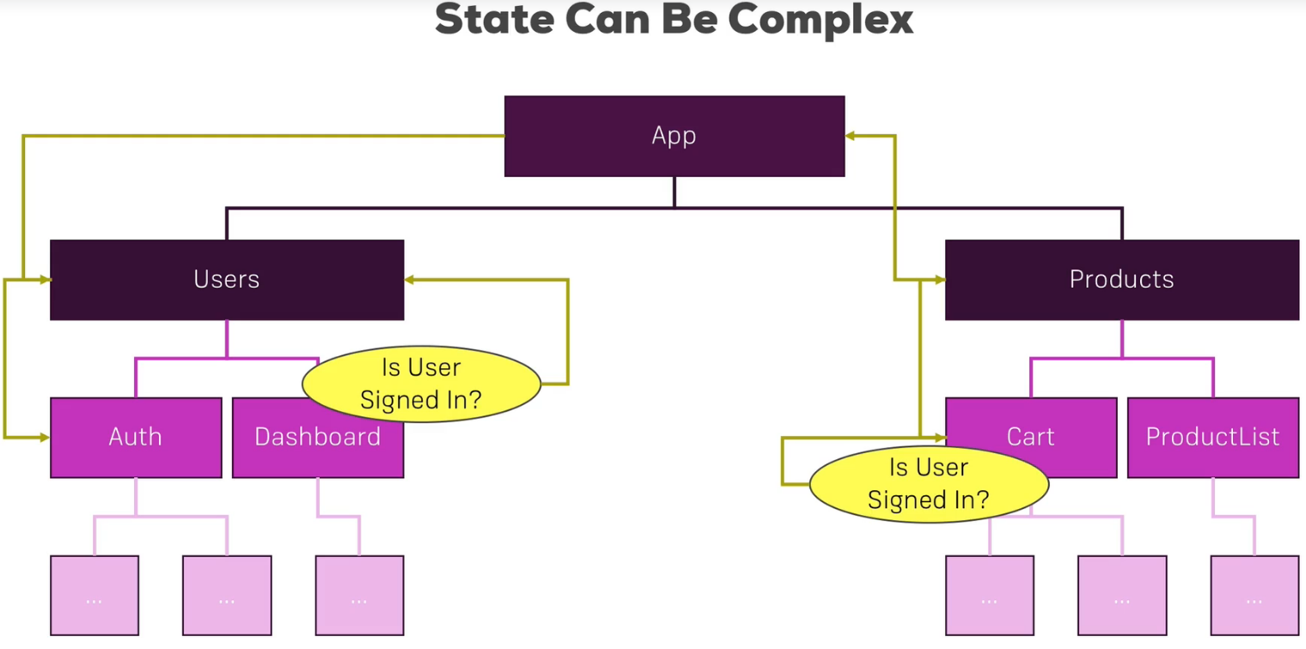  
=> We somehow need to create a connection between the Auth component and our Cart component here.  
=> Well that is super complex and a very long chain of props or query params or however we manage to pass data around.  
* It’s a pity that it is this difficult because in the end we’re writing JavaScript and we’re having a bundled JavaScript file as our output or a couple of bundles if we’re using Lazy Loading.  
* So in the end why can’t we just set some global variable which is a JavaScript object which stores our entire application state and which we can access from anywhere? Why do we have to take the complicated route with query params if all we do is just use JavaScript in the end?   
* The reason is that React’s reactivity system doesn’t react to changes in some global variable you defined. And it’s good that it doesn’t, that makes it so efficient.   
* However, having this global store still sounds very interesting and that’s exactly what Redux is about.  
**Understanding the Redux Flow**  
* Redux gives us a certain flow of data, a certain way of managing data that we can then nicely integrate with another package into the React app so that React does react to changes of data.  
* How does Redux work?  
* In the end it’s all about a central STORE we have in each Redux application.  
* This STORE stores the entire application state. You can think about it as a giant JavaScript object.  
* In React we have Components that probably want to manipulate or get the current application state.   
* Now it doesn’t do that by directly manipulating that central JavaScript object, that would not be picked up by React’s reactivity system and even worse - it would make our STORE pretty unpredictable. If we edit this from anywhere in our application, then we can never see where we made a certain change that broke our app for example. So we need to have a clear, predictable process of updating the state on which we can rely on and which is the only process that can change our state.   
* That is actually what Redux is all about - having a clearly defined process of how your state may change.  
* The first building block besides the Central STORE are **ACTIONS**, which are dispatched from your JavaScript code. In a React app they’re dispatched from within your components.  
* **An ACTION is just an information package in the end, with a TYPE. Something like add ingredient or remove ingredient - so a description you could say. Possibly it also holds a PAYLOAD - for example if the ACTION is add ingredient, we need to also pass the information: which ingredient, and that would also be part of that ACTION**.  
* So it’s an information package we’re sending out to Redux.  
* **That ACTION doesn’t directly reach the STORE, that ACTION doesn’t hold any logic, it doesn’t know how to update the STORE, it’s just a messenger**.  
* The thing changing the STORE is a **REDUCER** or REDUCERS (we can combine multiple REDUCERS into one) but in the end you’ll end up with 1 root REDUCER which is directly connected to your STORE in the end.  
* So the ACTION reaches the REDUCER and since the ACTION contains a TYPE, the REDUCER can check the TYPE of the ACTION - for example if it’s add ingredient and we then define the code for that TYPE of ACTION in the REDUCER.  
* The REDUCER in the end is just a pure function which receives the ACTION and the OLD STATE as input and which then spits our an UPDATED STATE.  
* The important thing is that the REDUCER has to execute SYNCHRONOUS code only. No asynchronous code, no side-effects, no HTTP Requests, nothing like that.  
* You’ll learn later how you can still implement asynchronous code but in REDUCERS it’s just input in, output out, nothing inbetween, no delay.  
* So the REDUCER spits out the UPDATED STATE which then is stored in the STORE again and replaces the OLD STATE and that has to be done in an immutable way - so we always return a NEW STATE which can be based on the old one but which is technically a new JavaScript object. Because objects are reference types in JavaScript and we want to make sure that we don’t accidentally change the OLD STATE.  
* So that is how the REDUCER handles the ACTION. Now the STORE is up to date.  
* How do we get the UPDATED STATE back into our component then?  
=> For that we use a **SUBSCRIPTION** model - the STORE triggers all SUBSCRIPTIONS whenever the state changes, whenever the state is updated in the STORE.  
=> And of course our component can SUBSCRIBE to STORE updates and it then receives that update automatically.  
* This is how simple it is, it works through a SUBSCRIPTION model and we simply say: Hey, I want to get notified whenever the state changes. Just as we say: Hey, I want to change the state, here’s an ACTION describing my plans.  
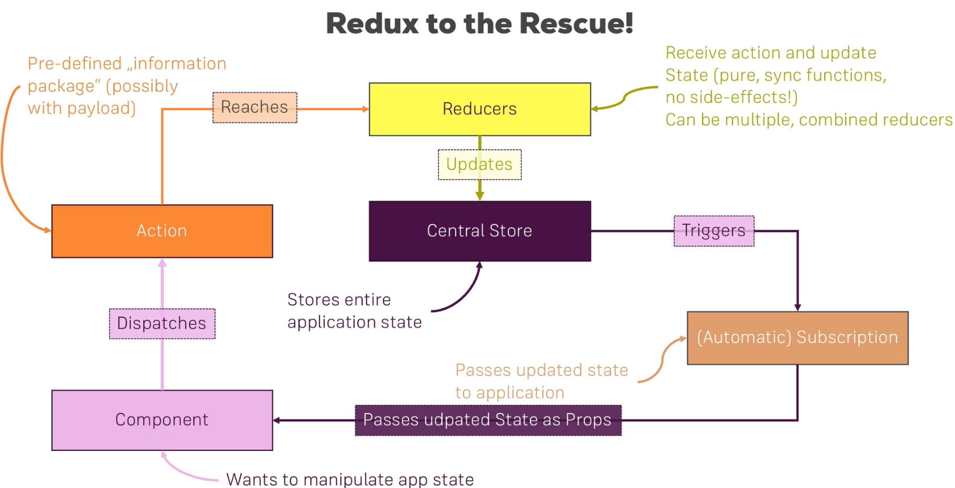  
* This is the Redux flow, this is how Redux works.

**Setting Up Reducer and Store**  
* This is the project we’re going to use.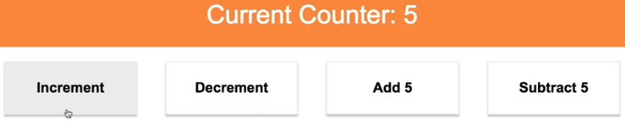  
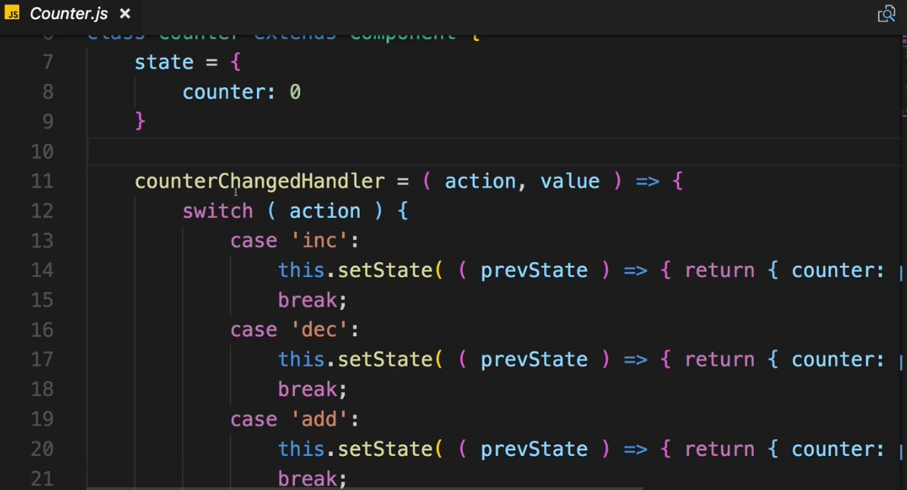 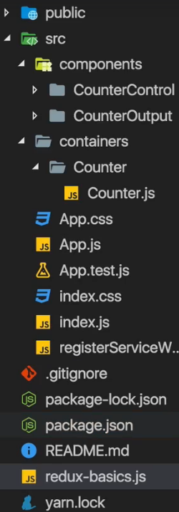  
**npm install --save redux**  
* Redux library works standalone and we’ll actually use it standalone for now but we’ll soon add it to our React application to see how it works together with it.  
* Creating `redux-basics.js` file next to App.js.  
* This file here won’t be holding any React code. We won’t include it into our React project.  
=> I’ll execute it with Node.js instead.  
=> Just to show the different concepts of Redux in 1 file and to show that it’s independent of React.  
* Now here I want to create everything we need to use Redux.  
1. => Store  
2. => Reducer  
3. => Dispatching Action  
4. => Subscription  
* We will use the import … from … in React but to be able to execute it with Node, I need to use the Node import syntax.  
* **redux.createStore** is a function but we don’t want to execute it now, just assign it to a const.  
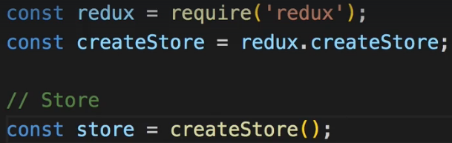  
* **createStore()** like this won’t do much though - a STORE needs to be initialized with a REDUCER because the REDUCER (**and remember we only have 1 REDUCER even if we combine multiple ones, they will be merged into one**) is strongly connected to the STORE. It’s the only thing that may update the state in the end. That’s why we need to pass the REDUCER to this creation function here - because it’s so closely connected to the state.  
* Therefore I actually need to create the REDUCER first before creating the STORE.  
* **The REDUCER function receives 2 arguments: the old state and the action. And then the function has to return 1 thing which is the updated state**.  
* The simplest REDUCER you can write simply returns the old state.  
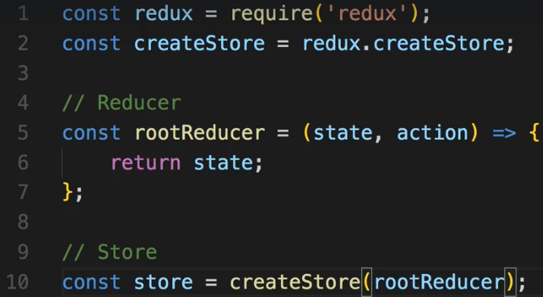  
* This STORE will hold an undefined state.  
=> **store.getState()** will get the state from the STORE.  
* The state is undefined because our rootReducer only returns the old state and we never initialize it.  
* Let’s create some initial state - a JavaScript object though theoretically it could also just be a number or anything like that so it doesn’t have to be an object but most often it is because we have more then 1 field in our global state most of the time.  
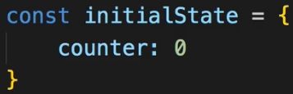  
* Now in the REDUCER I’ll use a feature provided by ES6 - I can initialize this **argument to the function** with a **default value**. Whenever this function is now called with this state argument being undefined, it will take the default value instead. Which will be the case when it’s creating the STORE where it will execute the REDUCER for the first time.  
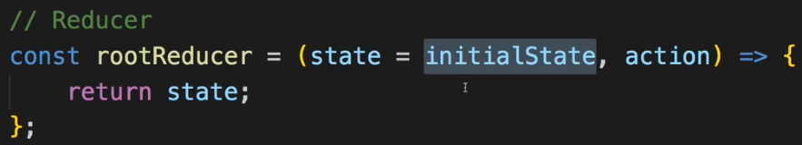  
* For all subsequent actions the REDUCER will have been executed 1 time so the current state then will be your initial state and you can start changing that.  
* So this is how we create a STORE with a REDUCER and how we initialize the state.  
* How do we now SUBSCRIBE to the state and dispatch ACTIONS?  
**Dispatching Actions**  
* Now I want to use the STORE and dispatch an ACTION.  
* An ACTION is dispatched by simply accessing the STORE and calling **store.dispatch()** which takes an ACTION as an argument - that should be a JavaScript object which needs to have a `**type**` property, this will later be an important building block in getting the information which TYPE of ACTION was dispatched and what we should do in the REDUCER.  
* TYPE is just some unique identifier, the convention is to use an UPPERCASE string.  
* Along with the TYPE there can be a PAYLOAD - that can be any other property like value, name, id, whatever you want. Or you could have a `payload` property which then could be an object {} grouping all the data you want to pass with the ACTION.  
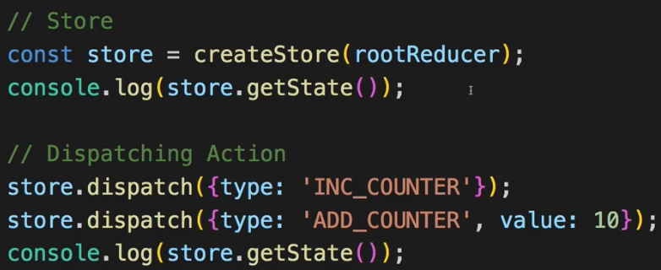 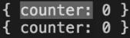  
=> The first output is the first console.log() and the second one is the second console.log().  
=> We didn’t implement any logic to do anything with it, that’s why it stayed the same.  
* In our REDUCER we get the ACTION as a 2nd argument, so of course we can react to different types of actions.  
* Inside of REDUCER you CAN’T set the state like this:  
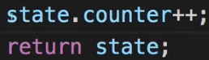 because it’s not immutable.  
=> So instead, you return a new JavaScript object where you may first copy the old state with the spread operator and then overwrite the one property you want to adjust. And if the `counter` were also an object, you’d have to copy it first too so that you never mutate any data, never, always do this immutably.  
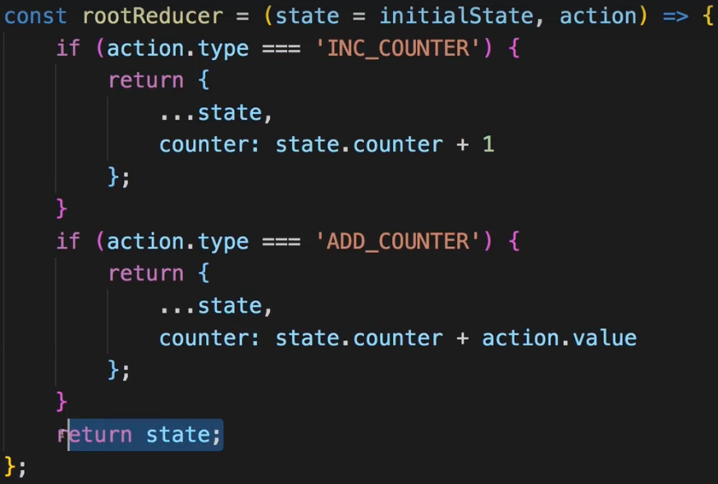  
* Now we only return state (the old one) if none of these if conditions apply.  
* Now we see { counter: 11 } for the second console.log().  
**Adding Subscriptions**  
* SUBSCRIPTIONS make sure that I don’t have to manually call store.getState() here in my code if I want to get the current state snapshot but to inform me whenever I need to get a new state because something changed. Because if I do it manually, I always have to guess if something changed.  
=> **store.subscribe()** method which takes 1 argument - a function which will be executed whenever the state is updated. So whenever an ACTION reached to the REDUCER.   
=> The function we pass into it doesn’t take any arguments, and then in the function body we can execute any code we want - on state updates.  
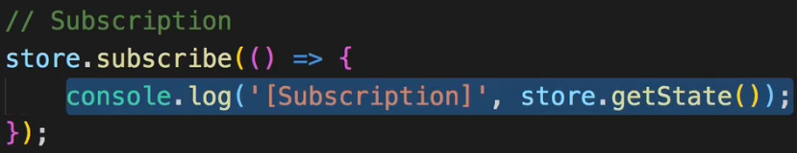  
* The store.getstate() method is the same as before - the difference is that I now know that I should get the state here because I know: Hey, something changed. And that SUBSCRIPTION actually of course typically is set up right after the STORE was created (position in code) so that we get informed about any future dispatches.  
* So notice that the SUBSCRIBE comes before DISPATCHING ACTIONS and this function in the store.subscribe() method will be executed whenever an ACTION is dispatched and mutates the STORE.  
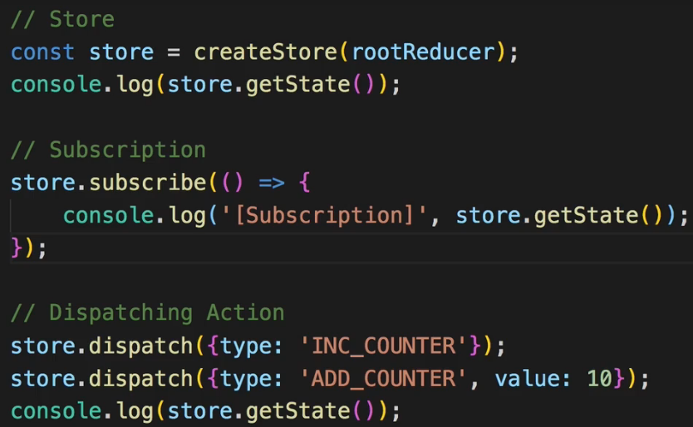 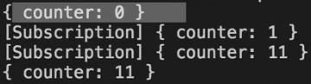  
* Now I get the 2 SUBSCRIPTION outputs not because the SUBSCRIPTION comes before the store.getState() but because it’s triggered whenever an ACTION is dispatched.  
* This is how SUBSCRIPTION works - it’s getting triggered whenever the state is updated.  
* Now this is showing us all the building blocks of Redux.  
* Let’s see how we connect React to Redux.  
**Connecting React to Redux**  
* Of course for such a simply application like this, Redux might be an overkill. But it is good to use a simpler application to practice the basics we’ll then apply to our course project.  
* The STORE should be created when our application starts.  
=> So the index.js file is a great place. This is where we mount our App component to the DOM.  
* I won’t create the REDUCER in this file, I’ll have more complex REDUCERS in React applications with a lot of code for different types of ACTIONS and therefore we typically store that logic into their own files.  
* There are different setups you’ll often see that there is a `**store**` folder in your project next to the components and containers folder and in there you can have a `reducer.js` file.  
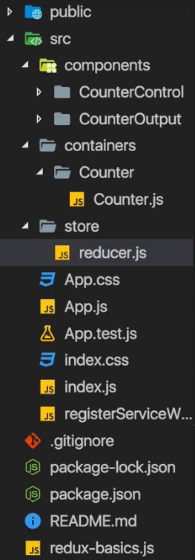 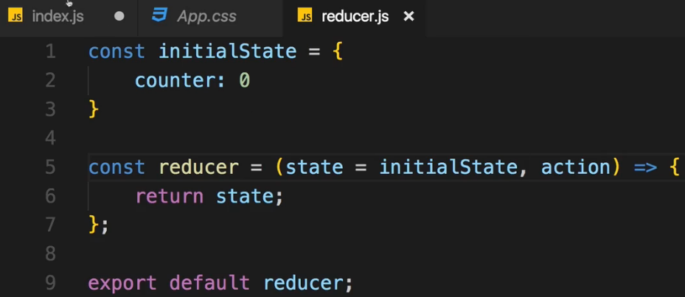  
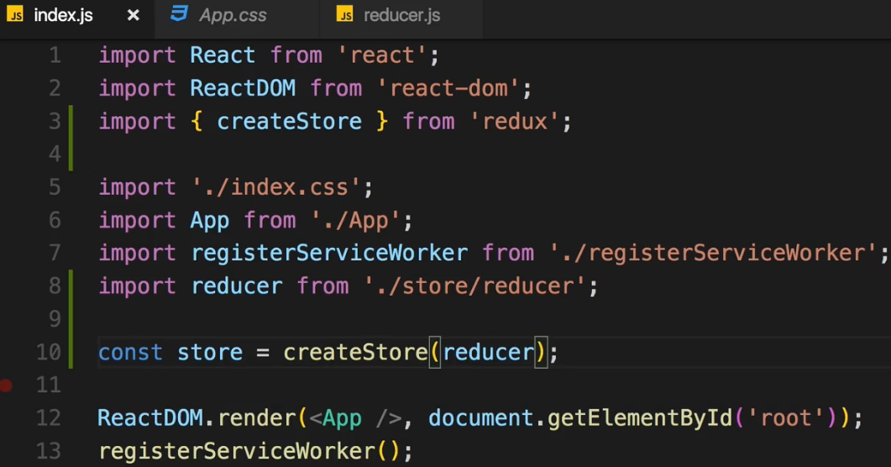  
* With that we’re creating the STORE successfully, with our own REDUCER.  
* Now we want to connect this STORE to our React application and we want to be able to get slices off the state in our React containers so that we can display the state or render something depending on which state the application has. And of course we wanna be able to dispatch ACTIONS.  
**Connecting the Store to React**  
* To connect it, I need a special package because Redux alone is standalone, is not connected to React.  
**npm install --save react-redux**  
=> We get a **Provider**.  
  
  
* Provider is a helper component which allows us to inject our STORE into the React components.  
* For hooking up the Provider component with our STORE here, I need to set up a special property.  
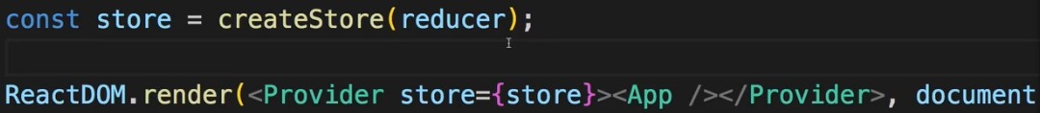  
* Now with that, the STORE is connected to our React application. At least a bit. There’s still something missing.   
=> How do we actually get the data from the STORE like the `counter` value in our Counter.js container.  
=> For that we need to connect this Counter individual container with the STORE or - to be precise - in the end what we want to do is set up a **SUBSCRIPTION** here. We won’t do it manually by calling subscribe like in the node file, we will use a feature provided by that `react-redux` package instead.  
* It’s still our container components that manage the state - they don’t manage it on their own anymore but they are now the places which receive it from Redux.  
* We still use container components which then may distribute it down to their components which they embed but we never change our pattern of having a few selected components getting the state and passing it on, this pattern is still the same, even though we’ll eventually get rid of its state later.  
=> **connect** is a function which returns a HOC - Higher Order Component.  
  
* We use it on the export, however, not to wrap it like this: connect() but instead connect itself is a function which returns a function which takes then a component as input. So connect is not really a HOC, it’s a function which returns a HOC.  
* The whole idea behind this complex setup simply is that connect() now also can be called as a function and since it returns a function, we then execute the result of connect() of this function execution, we execute this too and pass a counter and to this first function execution we can pass some configuration for this given container.  
* We pass 2 pieces of information to connect: 1st which part of the whole application state is interesting to us (which slice) and 2nd which ACTIONS I want to dispatch.  
=> So the ACTIONS we want to dispatch and the state we want to get.  
* We do this before the export.  
* You store instructions about how the state managed by Redux should be mapped to props you can use in this container, because that’s important - the state managed in Redux is not received as state here because state is the thing you change internally from within a component. Those times are over. Redux is now the place where we manage and change the state. So we don’t want to get anything which we can’t change internally. And PROPS aren’t changed internally, that is why we map the Redux state to PROPS. This is where the name I chose comes from - mapStatetoProps.  
* It actually stores a function which expects the state stored in Redux as the input and returns a JavaScript object which is a map of prop names and slices of the state stored in Redux.  
* Now this function will eventually by executed by the `react-redux` package because we’ll pass it to it. It’s our way of configuring which kind of information we need.  
* We should define prop names and then you access state and this state here again will be given to you by `react-redux` which of course will reach out to your Redux state which of course in turn is the state you set up here with `initialState` in `reducer.js` so there will be a `counter` property available. And with that we’re saying: Hey, please give me the value of the `counter` in our global state managed by Redux and give it to me in the form of a property named `ctr` which I can then use in here in Counter.js. We pass this to connect(). And now connect which also then receives the Counter component on the function returned by that first function, connect then gives us this Counter container with access to this `ctr` property.  
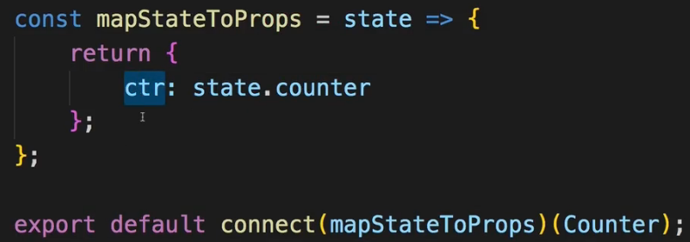  
* This now allows us to output the `ctr` property. Using `this.props.ctr` instead of `this.state.ctr`.  
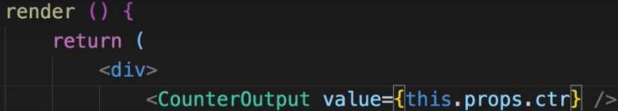  
* Right now we have no way of changing the state with the buttons though, let’s do that next.  
**Dispatching Actions form within the Component**  
* So we did get our slice of the state here and output it with the `ctr` prop.  
* Now I want to be able to dispatch ACTIONS.  
* And for that we need to find out how we can dispatch ACTIONS from within our components.  
* When we used it standalone we simply called store.dispatch(). Now we don’t have access to the STORE in our container - at least not directly. We got access through **connect()()** though. And just as we were able to pass some information about which slice of the state we want to get, we can also pass a 2nd configuration.  
* I’ll name it mapDispatchToProps because here I’ll say: which kind of ACTIONS do I want to dispatch in this container.  
* This also stores a function which will receive the `dispatch` function which we can execute, as an argument. Just as we had .dispatch() available on store, we get this helper function which will call store.dispatch() behind the scenes.  
=> We then here also return a JavaScript object where we can define some prop names which will hold a reference to a function which should eventually get executed to dispatch an ACTION.  
=> This property’s value should be an anonymous function. This function here will in the end be available through this property and therefore whenever this property is executed as a function, for example if we assign it to an `onClick` handler, then this `dispatch()` method here is going to get executed. And to this method I can now pass a JavaScript object where we need to set the TYPE.  
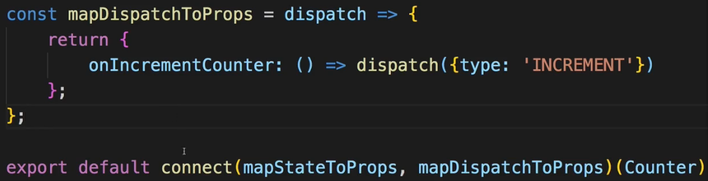  
* By the way if you ever have a case where you don’t have any ACTIONS in your container, you just leave it out as we did before, OR if you have a container which only needs to dispatch ACTIONS but doesn’t need a slice of the state, you simply pass NULL as the 1st argument.  
  
* Now let’s adjust the REDUCER to handle this ACTION.  
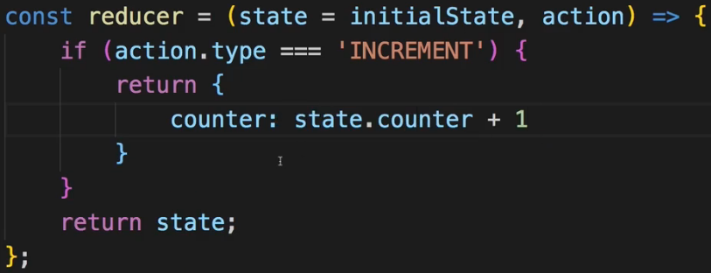  
* We could use the …state spread operator but we don’t have to now since we only have 1 property.  
**Assignment 4: Time to Practice - Dispatching Actions**  
<https://www.udemy.com/react-the-complete-guide-incl-redux/learn/v4/t/practice/18408>   
**Passing and Retrieving Data with Action**  
* In the Assignment we added 3 new ACTIONS we can dispatch.  
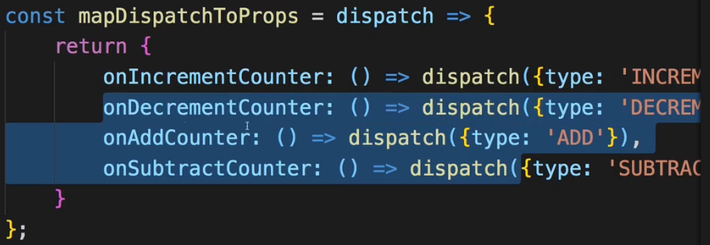 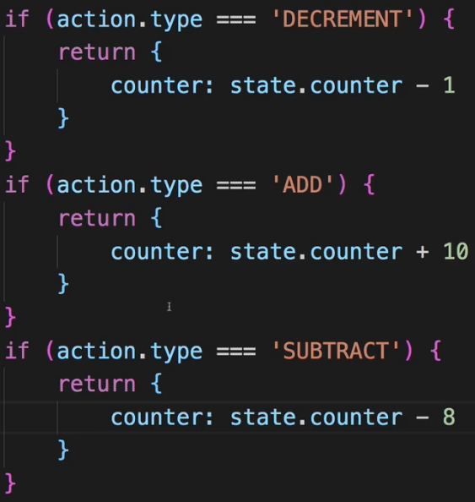  
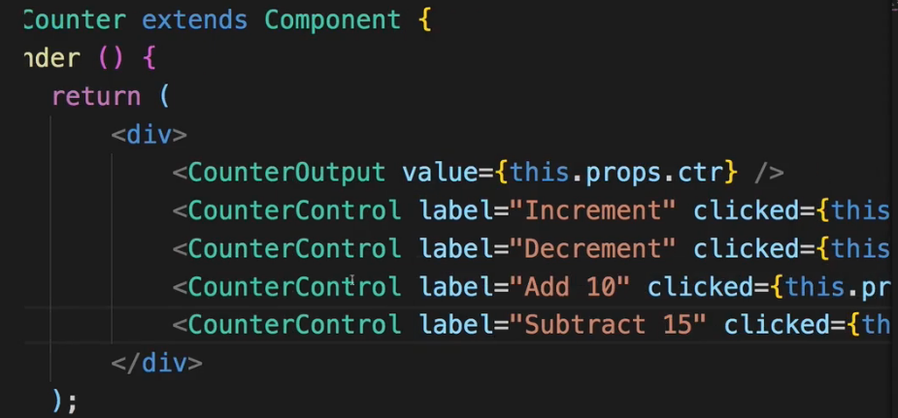  
* Now for ‘ADD’ and ‘SUBTRACT’ it would make sense to also receive a **PAYLOAD** - some additional data passed along with the ACTION TYPE instead of hard-coding it.  
* If you want to pass more then 1, it’s common to name it `payload: {}`, else any name you want, you can even pass multiple properties along with type, not using the object of course.  
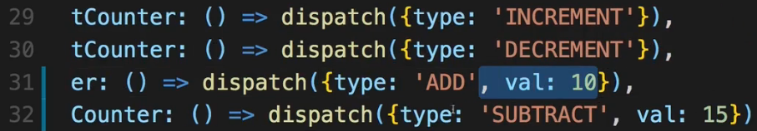 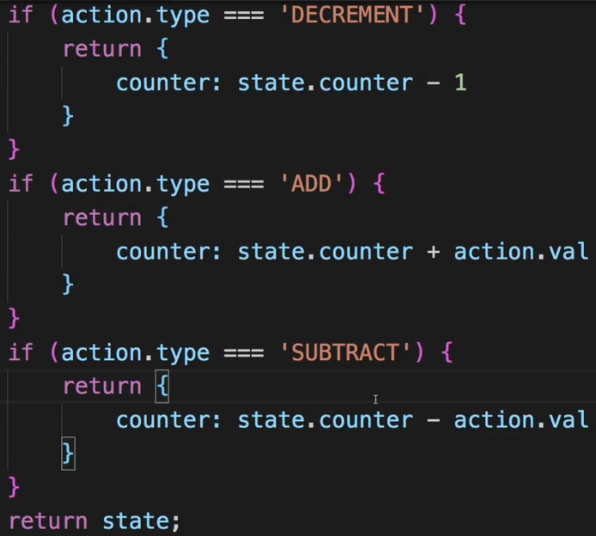  
* Now since we’re inside of the container, we could easily connect this number/s to some input field we have.  
**Switch-Case in the Reducer**  
* If we look at our REDUCER, there’s a lot of code replication, a lot of `if` statements, now there’s nothing wrong with that if you like that. But we could also use a `switch` statement. We could switch the ACTION TYPE and then define multiple cases.  
=> I don’t need to add a `break` statement because `return `automatically exists out of this function.  
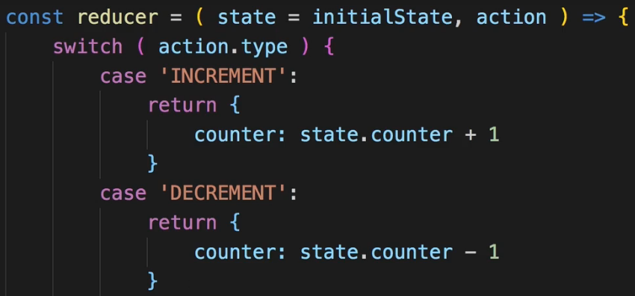  
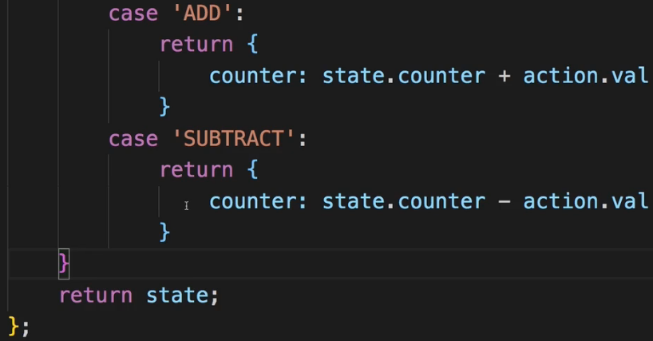  
=> Now our REDUCER is a bit leaner and a bit easier to read because it’s very clear that we’re looking at the ACTION TYPE and then we’re just handling different cases.  
=> And if we don’t make it into any of these cases, we always have the default `return` statement at the end which returns our initial state or if this was already set, the current state. This is especially important since you have to keep in kind that if we were to dispatch an ACTION which has a TYPE which is not covered here, we would still run through that REDUCER because whenever you dispatch something, it goes through that single REDUCER you have in your application and therefore if that REDUCER doesn’t handle that ACTION TYPE you dispatched, you have to return the current state to not break your application.  
**Updating State Immutably**  
* Let’s dive into more state management.  
* Let’s add a new state in our reducer.js.  
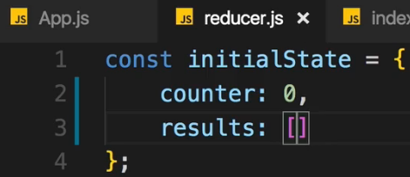  
* In Counter.js let’s add a new button.  
* And this result should get added to an UL which we create below that button.  
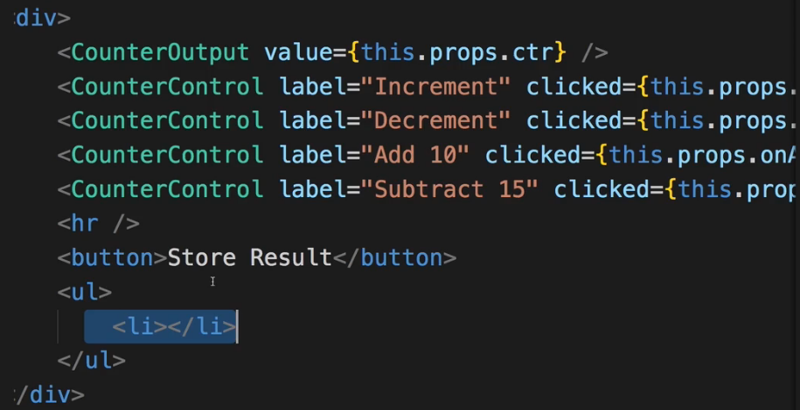  
* Now the idea is that if I click the “store result” button, that I simply add the current `counter` value to my result list here.  
=> So for that I of course want to dispatch an ACTION whenever this button is clicked and then push this new result to this `results` array, update that array with it and of course take the current `counter` as an input.  
* Additionally if I click one of these results - so one of these list items, I want to remove it from the array.  
=> We need 2 new dispatch functions.  
* In the onStoreResult there should be a value and that should be the current `counter`. Now this is something I don’t need to pass as a PAYLOAD though because since the `counter` is part of my application state, I will have access to it in my REDUCER anyways.  
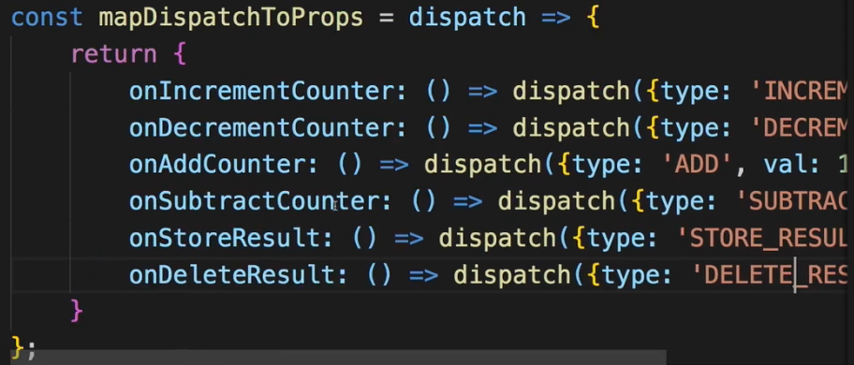  
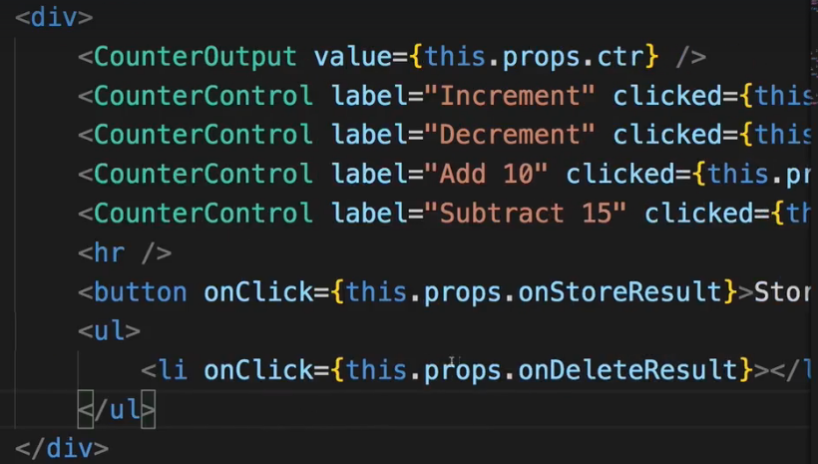  
* If we now click on the button, nothing happens and we don’t even get an error.  
=> Important takeaway: **you can dispatch ACTIONS which you don’t handle in the REDUCER**.  
=> We get to the `return state;` line.  
* In the STORE_RESULT we want to return an updated version of my state. And it should be immutable.  
* **Now we have to add the previous state, not just return the { counter } because now the `counter` is no longer the only thing we have in our state, so just returning `counter` would remove the `results`. It doesn’t get merged with the old state or anything like that unlike setState()**.  
* So we should copy the old state properties and then only update the ones which need updating. And this should happen immutably.  
=> **1 way** of doing that is with **Object.assign({}, state)**:   
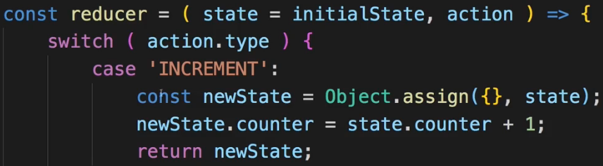  
=> This will basically clone the old object in an immutable way, giving us a new JavaScript object which has all the properties of the old object but is a technically different object, a that is important due to the way object and arrays work in JavaScript with the reference types vs primitive types.  
=> The **shorter way** is to simply return a JavaScript object {} and there distribute all the properties of the old state using the **spread** **operator**.  
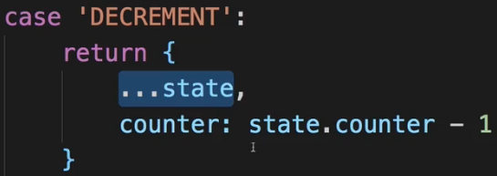  
=> This simply tells JavaScript: return a JavaScript object, take all the properties and values of the state argument which is our old state, distribute these properties with their values in this new object. And then since we add an additional property, add this property to the object or if it already was present due to us distributing the old state as it would be for the `counter`, overwrite this. But only this, leave `results` untouched.  
* We should always update the state immutably, don’t touch the old state.  
=> **.concat()** => **is like .push() but while .push() manipulates/touches the original value, .concat() returns a new array which is the old array + the argument you add to .concat(). So it’s an immutable way of updating an array by adding an item**.  
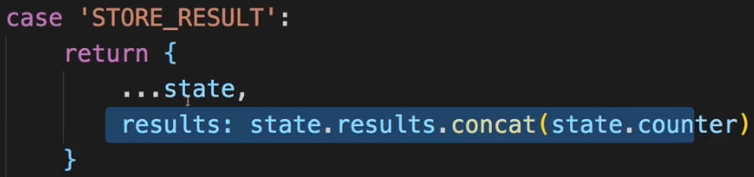  
* We want to store a snapshot of the `counter` and push it to the `results` array.  
* Now we can use it in our Counter.js component.  
* There we can now bind it in **mapStateToProps** - to a new prop.  
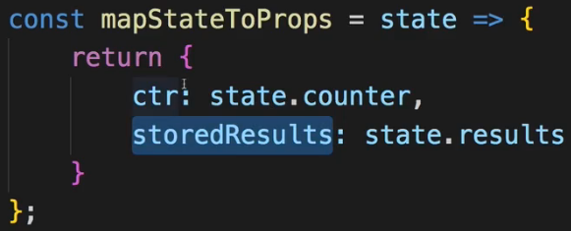  
* Now we can use it to output the results as lists.  
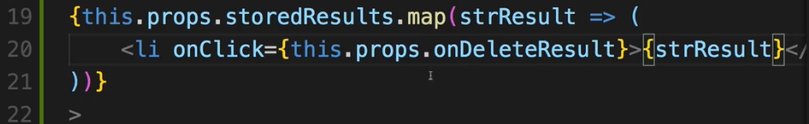  
* **Now I want to create an ID in there as well to use it as a `key` prop**.  
  
  
* We can use **new Date()** as an ID since it is unique.  
**Updating Arrays Immutably**  
* Now I want to handle the case where I want to delete a result.  
* Adding an item immutably was possible with `**.concat()**`.  
* Now you typically remove items from an array by getting the index of the item you want to remove and then we could call **.splice(id, 1)**. This, however, mutates the original array.  
=> There are a couple of ways, I’ll show you 2.  
=> 1. => Create a copy of your array by **creating a new array** and **using the spread operator** to distribute all the elements into that new array.  
* **Important: if the elements in the array we objects - as the actually are here - the objects themselves are still pointing to that same object they did before. So if you change a property in one of the elements themselves, this isn’t enough. If you just plan on removing an object though, that is okay because you won’t touch the object, you just remove it from the array**.   
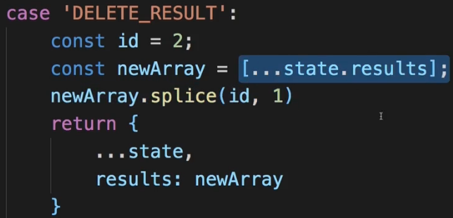  
=> 2. => The way you see more often is to use the `**.filter()**` method.  
=> A `.filter()` returns a new array, doesn’t touch the old one, creates a new one. It takes a function as an input, the function is executed on each element in the array and determines whether this element fulfills a certain condition to make it into the new array which is returned.  
* If you do for example this:  
  
then you just create a copy of the old array.  
* We can use a 2nd argument in the function - index:  
  
=> We have a state of elements where we have elements of this shape:  
  
* We don’t need the index =>  
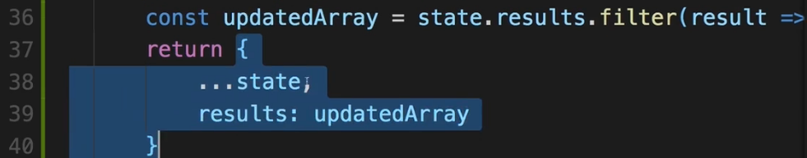  
  
=> Now let’s pass the ID along with the action.  
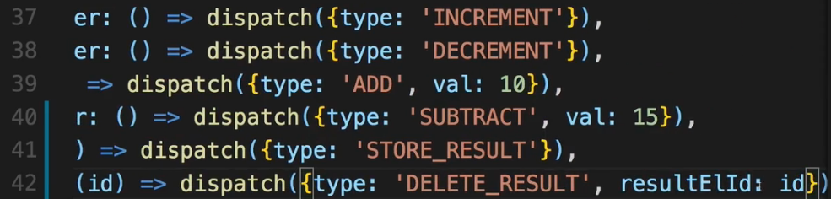  
* Now to receive that here in the onDeleteResult function:  
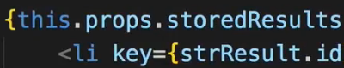  
=> It’s referring to that new Date() snapshot.  
* You learned how to delete elements immutably with `.filte r()` and you learned how to pass ACTIONS from within your UI to an ACTION by expecting the argument to get from the UI in `mapDispatchToProps` and then passing it along with the ACTION and of course by then passing that argument you are expecting here, from within your UI by wrapping this prop you execute - in an anonymous function, which allows you to pass data along with the function call.  
* This is another core building block - working immutably on deletes and passing ACTION PAYLOADS from the UI over mapDispatchToProps to the STORE.  
**Immutable Update Patterns**Immutable Update Patterns on reduxjs.org: <http://redux.js.org/docs/recipes/reducers/ImmutableUpdatePatterns.html>  
**Updating Nested Objects**The key to updating nested data is **that every level of nesting must be copied and updated appropriately**. This is often a difficult concept for those learning Redux, and there are some specific problems that frequently occur when trying to update nested objects. These lead to accidental direct mutation, and should be avoided.  
**Common Mistake #1: New variables that point to the same objects**Defining a new variable does not create a new actual object - it only creates another reference to the same object. An example of this error would be:

1. function updateNestedState(state, action) {
2. let nestedState = state.nestedState;
3. // ERROR: this directly modifies the existing object reference - don't do this!
4. nestedState.nestedField = action.data;
6. return {
7. ...state,
8. nestedState
9. };
10. }  
    This function does correctly return a shallow copy of the top-level state object, but because the nestedState variable was still pointing at the existing object, the state was directly mutated.  
    **Common Mistake #2: Only making a shallow copy of one level**Another common version of this error looks like this:
11. function updateNestedState(state, action) {
12. // Problem: this only does a shallow copy!
13. let newState = {...state};
15. // ERROR: nestedState is still the same object!
16. newState.nestedState.nestedField = action.data;
18. return newState;
19. }  
    Doing a shallow copy of the top level is not sufficient - the nestedState object should be copied as well.  
    **Correct Approach: Copying All Levels of Nested Data**Unfortunately, the process of correctly applying immutable updates to deeply nested state can easily become verbose and hard to read. Here's what an example of updating state.first.second[someId].fourth might look like:
20. function updateVeryNestedField(state, action) {
21. return {
22. ...state,
23. first : {
24. ...state.first,
25. second : {
26. ...state.first.second,
27. [action.someId] : {
28. ...state.first.second[action.someId],
29. fourth : action.someValue
30. }
31. }
32. }
33. }
34. }  
    Obviously, each layer of nesting makes this harder to read, and gives more chances to make mistakes. This is one of several reasons why you are encouraged to keep your state flattened, and compose reducers as much as possible.  
    Inserting and Removing Items in Arrays  
    Normally, a Javascript array's contents are modified using mutative functions like push, unshift, and splice. Since we don't want to mutate state directly in reducers, those should normally be avoided. Because of that, you might see "insert" or "remove" behavior written like this:
35. function insertItem(array, action) {
36. return [
37. ...array.slice(0, action.index),
38. action.item,
39. ...array.slice(action.index)
40. ]
41. }
43. function removeItem(array, action) {
44. return [
45. ...array.slice(0, action.index),
46. ...array.slice(action.index + 1)
47. ];
48. }  
    However, remember that the key is that the original in-memory reference is not modified. **As long as we make a copy first, we can safely mutate the copy**. Note that this is true for both arrays and objects, but nested values still must be updated using the same rules.  
    This means that we could also write the insert and remove functions like this:
49. function insertItem(array, action) {
50. let newArray = array.slice();
51. newArray.splice(action.index, 0, action.item);
52. return newArray;
53. }
55. function removeItem(array, action) {
56. let newArray = array.slice();
57. newArray.splice(action.index, 1);
58. return newArray;
59. }  
    The remove function could also be implemented as:
60. function removeItem(array, action) {
61. return array.filter( (item, index) => index !== action.index);
62. }  
    Updating an Item in an Array  
    Updating one item in an array can be accomplished by using Array.map, returning a new value for the item we want to update, and returning the existing values for all other items:
63. function updateObjectInArray(array, action) {
64. return array.map( (item, index) => {
65. if(index !== action.index) {
66. // This isn't the item we care about - keep it as-is
67. return item;
68. }
70. // Otherwise, this is the one we want - return an updated value
71. return {
72. ...item,
73. ...action.item
74. };
75. });
76. }  
    Immutable Update Utility Libraries  
    Because writing immutable update code can become tedious, there are a number of utility libraries that try to abstract out the process. These libraries vary in APIs and usage, but all try to provide a shorter and more succinct way of writing these updates. Some, like [dot-prop-immutable](https://github.com/debitoor/dot-prop-immutable), take string paths for commands:
77. state = dotProp.set(state, `todos.${index}.complete`, true)

Others, like [immutability-helper](https://github.com/kolodny/immutability-helper) (a fork of the now-deprecated React Immutability Helpers addon), use nested values and helper functions:

1. var collection = [1, 2, {a: [12, 17, 15]}];
2. var newCollection = update(collection, {2: {a: {$splice: [[1, 1, 13, 14]]}}});

They can provide a useful alternative to writing manual immutable update logic.  
[Immutable Data#Immutable Update Utilities](https://github.com/markerikson/redux-ecosystem-links/blob/master/immutable-data.md#immutable-update-utilities) section of the [Redux Addons Catalog](https://github.com/markerikson/redux-ecosystem-links).

**Outsourcing Action Types**  
* The action name in reducer.js has to match the name in the counter.js where we dispatch the action, any typo makes it not work and it might be hard to find out.  
=> Therefore it is a good practice to outsource your ACTION TYPES into contants in your application so that you always just import a constant and eliminate the danger of mistyping. This is especially useful as your application grows.  
=> Adding a new file in the `store` folder: `actions.js`.  
* Now theoretically the name of the constant and the identifier don’t have to match but it is a good practice.  
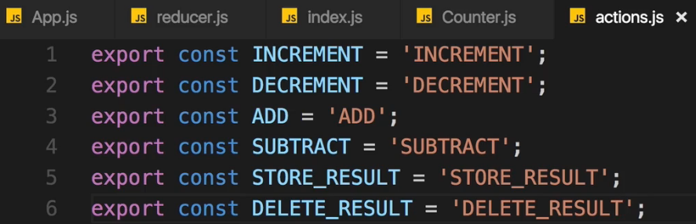  
* So now we have this extra file where we export all these ACTIONS.  
* This now allows us to go to the REDUCER and import the ACTIONS from there.  
  
* The actionTypes is now an object which has all these constants as properties.  
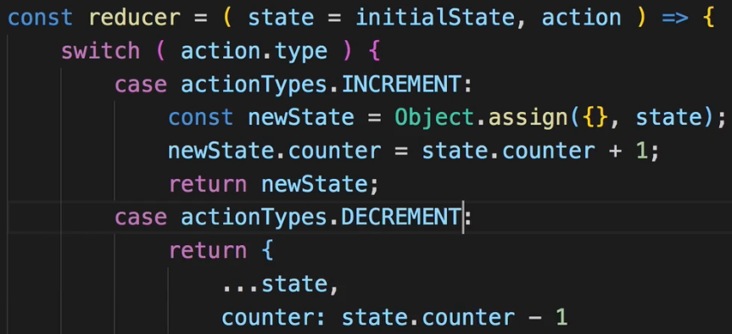  
=> **The huge advantage of this approach simply is that we’re now importing our constants here and if we mistype a constant name, we’ll actually get an error. This is why you use this approach**.

* And then I do the same where I dispatch them.  
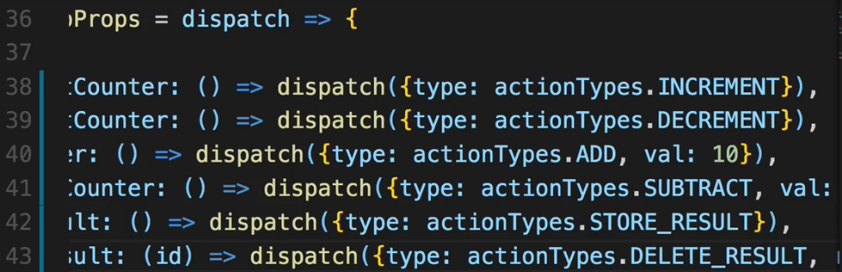  
**Combining Multiple Reducers**  
* There is something else we do a lot of our application grows - using multiple REDUCERs.  
* All ACTIONS in the end go through only 1 REDUCER.  
* But Redux gives us a utility method we can use to combine multiple REDUCERs into one.  
* In our tiny applicatin, we could have 1 REDUCER which handles the `counter` and 1 REDUCER that handles the `results`. Even though they’re somehow related, they technically are different or they manage different parts of the app so splitting it up might make sense.  
=> Adding a `reducers` folder in the `store` folder.  
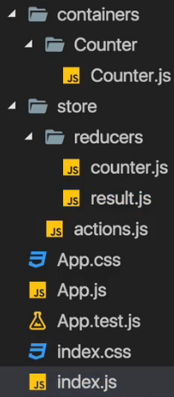 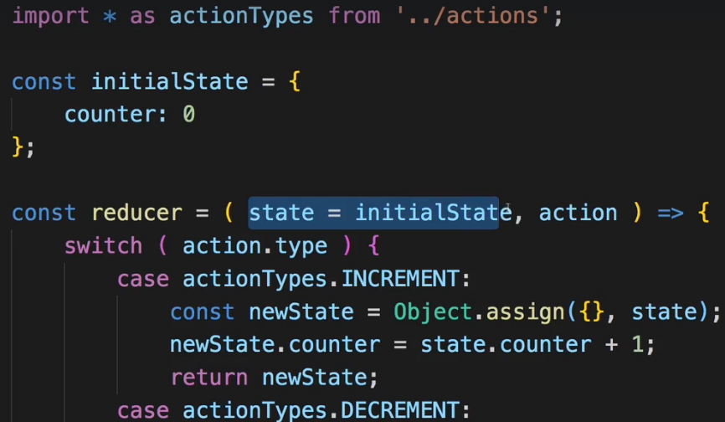 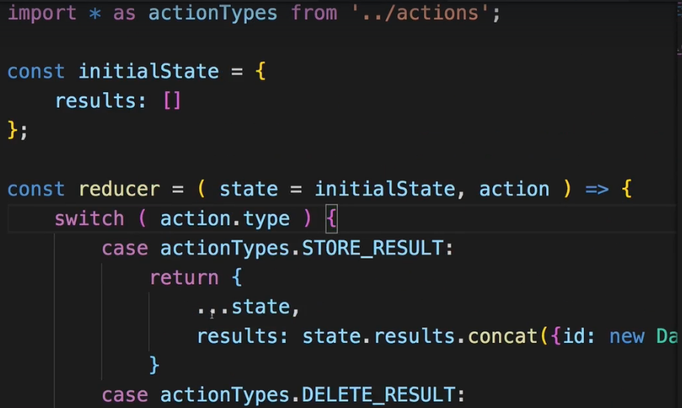  
* We can rename the actual REDUCER to counterReducer or just leave it as reducer.  
* Notice that I still access `state.counter` because in the end the 2 REDUCERs are going to get merged together into 1 global state so there is still going to be a `counter` state in there.  
* In index.js:  
  
=> **combineReducers**.  
  
=> This is a function which takes a JavaScript object, mapping our REDUCERs to different slices of our state as input and merged everything into 1 state and 1 REDUCER for us.  
=> In the object we now simply can create sections of our app so to say, and map the REDUCERs to the property names you choose.  
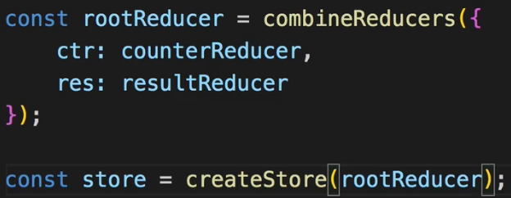  
* So now we’re telling Redux in the end: Hey, I got 2 different feature areas in my application, ctr and res, please use these REDUCERs for each of them and merge everything together into 1 STORE, into 1 state, into 1 REDUCER.  
=> And then we pass it to our STORE.  
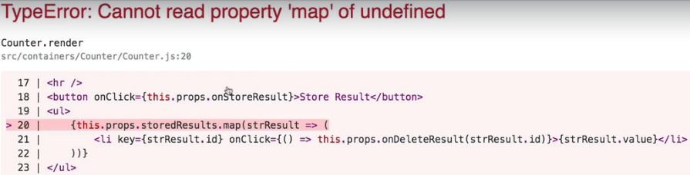  
=> Now we get an error. The problem is that the `storedResults` where we map through all the stored results, this won’t work because `this.props.storedResults` now refers to undefined. This happens due to us combining REDUCERs.  
=> Now we will have 1 state in the end but to avoid naming conflicts, Redux adds 1 level of nesting where it has 1 state object but basically with these keys (ctr, res) in combineReducers as properties which give us access to the sub-states for these feature areas you could say.  
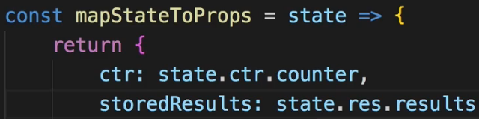  
* Now that part works but if we click Store Results, it’s not really displaying them.  
=> The storedResults is actually undefined because in the resultReducer we do store a snapshot here for state.counter and this doesn’t work because this result REDUCER doesn’t have a `counter` property. And inside this REDUCER function, it basically has no access to the global state, so adding .ctr won’t help. We only have access to the state of that REDUCER function.  
=> So if we are in a REDUCER where we need to get a value from the global state, we should simply get it as an ACTION PAYLOAD. And this is generally how your REDUCERs work anyways most of the time. It’s old state + ACTION + optionally ACTION PAYLOAD and you return a new state.  
  
* In Counter.js:  
  
* On the button in Counter.js:  
  
* By the way if you hit the Store Result button really fast, you get an error because some IDs will be the same since it’s based on the current date. That date ID is just a temporary solution for now.  
**Understanding State Types**  
* Before we finish this module and dive into more advanced Redux concepts such as running asynchronous code which we haven’t covered at all yet, let me walk you through different TYPES OF STATE and answer the question: should every state be handled through Redux? Is this always the approach you should follow? Do you always have to use Redux to begin with? Well the question whether you use Redux depends on the size of your application and the complexity of your state.  
* For any decent medium size or big application using Redux and managing the state there is probably a good idea but then still we have to ask: which state should be used through Redux? Because you shouldn’t necessarily manage all the state in it.  
* Let’s have a look at the various TYPES OF STATE, some examples and whether you should use Redux for them or not.  
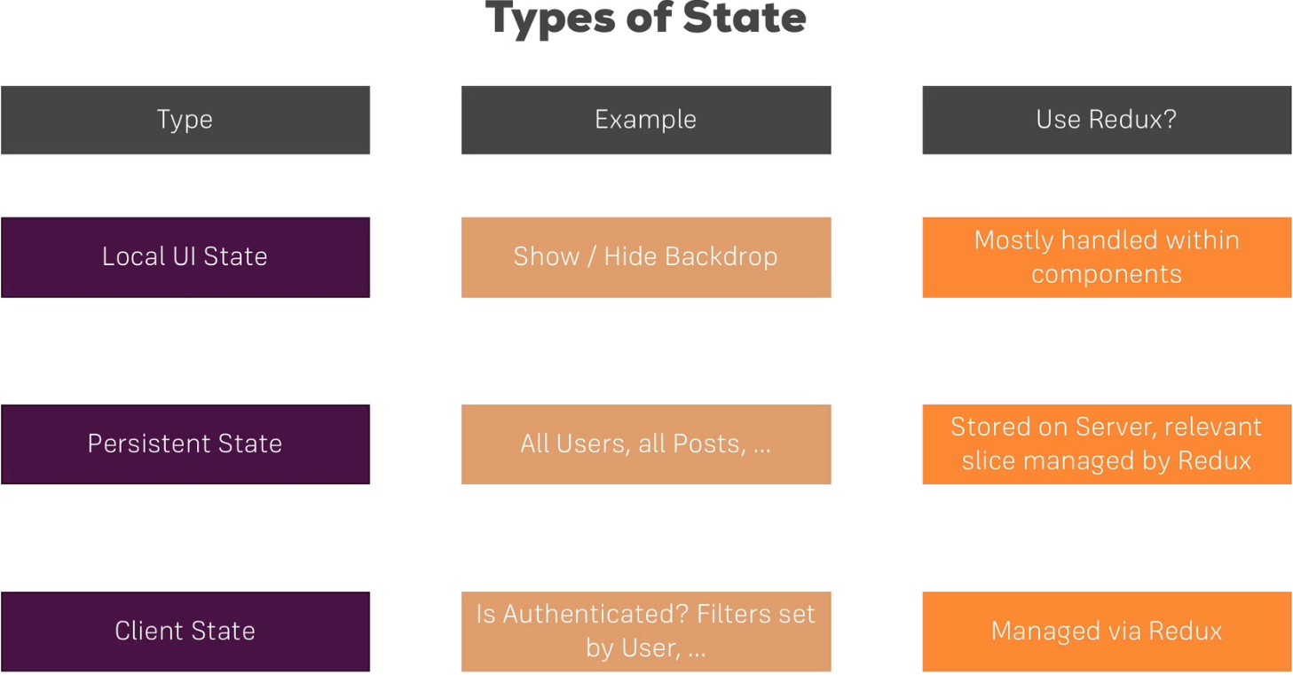  
=> **Local UI State** - you can use Redux for that, you can have a showModal property in your global state, dispatch an ACTION to set it to true and dispatch an ACTION to set it to false, then connect your component and listen to that property to conditionally render a modal or not. But that might be an overkill. Oftentimes you can handle it within your components, just as we did it before.  
=> **Persistent State** - this means the state you typically also store in server-side databases, like the users of your application, all posts of a blog, all burger orders, stuff like that. Here you typically do use Redux but of course not for all the data you have in your server-side database because Redux of course is just for managing the state in your application as long as your application is alive.  
* And always keep in mind - when the user refreshes your page, your state is gone. So Redux is not a replacement for a database, instead, you store such data on a server but the relevant slices are managed by Redux. So the posts you’re currently displaying, the users you currently need to display, the posts the user currently may edit. These things are loaded and stored in Redux so that you have them available, so that you can render them to the screen but that might not include all the data you have in your database.  
=> **Client State** - then we have a typical client state, things like: is the user authenticated? Or filters set by the user, so if you have a dropdown allowing the user to filter your posts. That’s not data you store in your database, you can’t store if a user is authenticated because if he enters wrong login information, you don’t need to store that on the server necessarily. Also the filter set by the user - you might not store that on the server because it’s not that important to store it in a database. You definitely need to be aware of the current filter settings on your client - in your JavaScript code, in the React application though. This is the state you definitely use Redux for because it might affect multiple components or areas of your application. For example if the user is authenticated, it might be important for a lot of components in your app and there Redux really shines because this central storage then offers a huge advantage.  
**Assignment 5: Time to Practice - Redux Basics**  
<https://www.udemy.com/react-the-complete-guide-incl-redux/learn/v4/t/practice/18410>   
**Combining Local UI State and Redux**  
* So we had the Assignment where we can create a person by clicking an Add Person button. And we add the age randomly.  
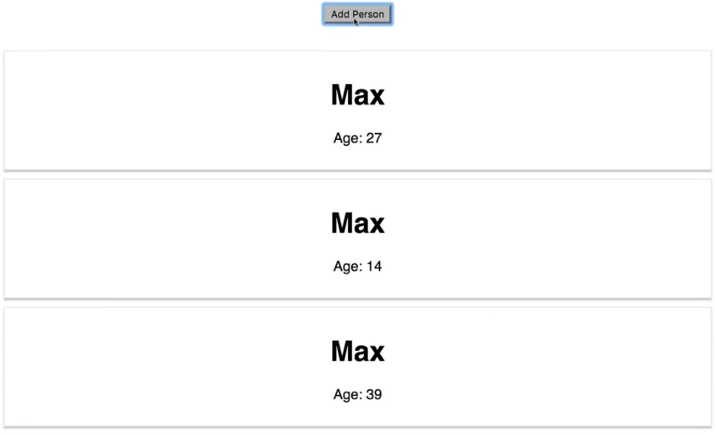  
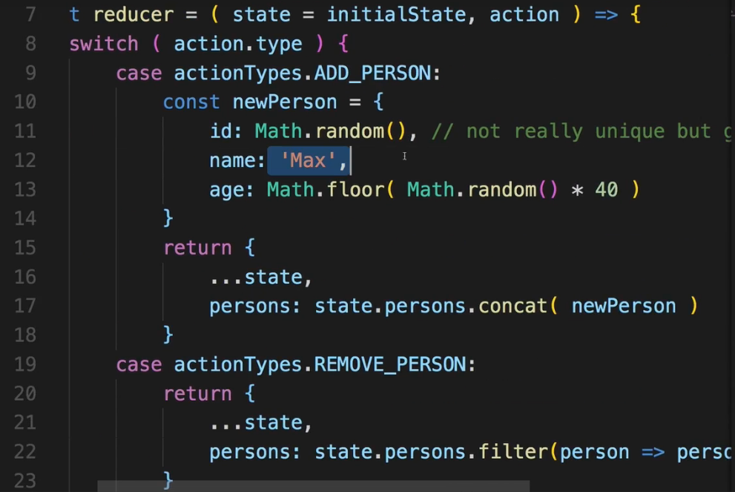 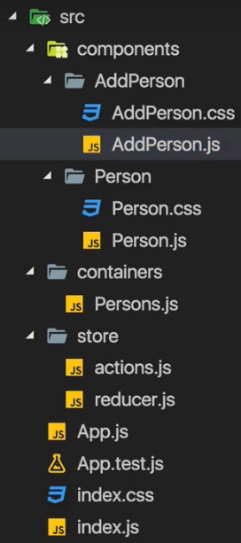  
* Of course it would be a typical use case to have input fields for the users to use to specify these values. How would that work?  
=> It’s a typical case of **Local UI State**.  
* You did of course learn over the last modules in this course that for user input we also handle this with setState() and in the state in general and for that we don’t need to use Redux just to store the value the user inputs. We need it then if we want to creat a person with the input but just to handle each keystroke and use two-way binding, we don’t necessarily use Redux.  
* So in AddPerson.js where we have our Button, let’s add inputs.  
* Now we can turn AddPerson into a container using the class keyword to manage the state of these inputs.  
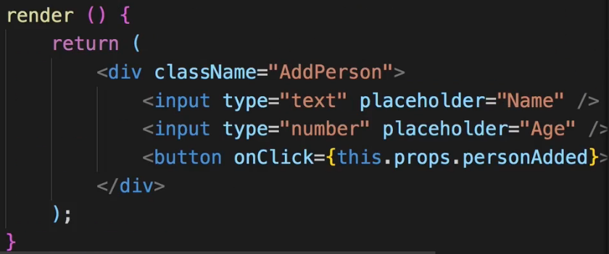 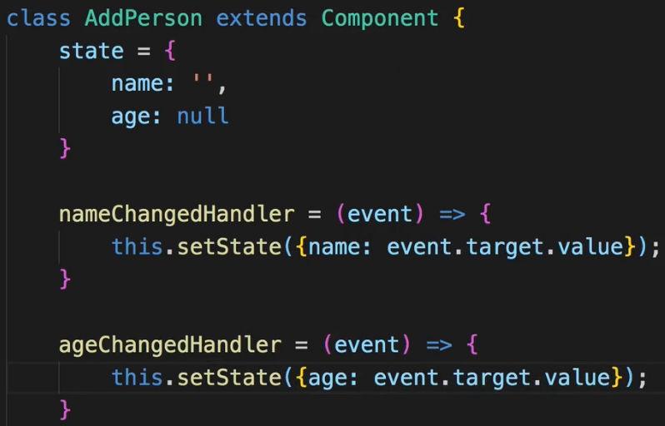  
* We now also need to bind the `value` to have two-way binding so that our keystrokes are actually reflected in the input.  
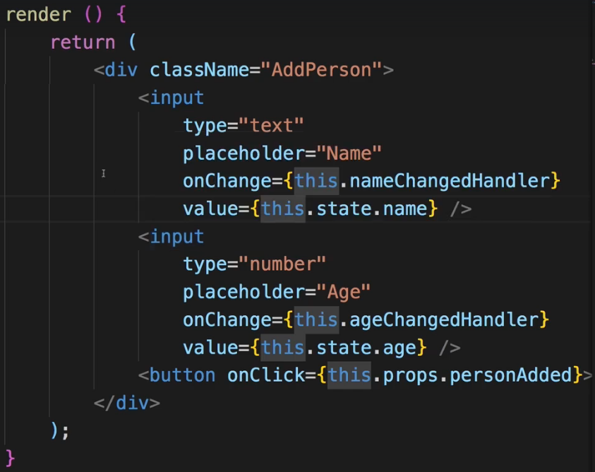  
* So far that is all the stuff we learned before this module, it has nothing to do with Redux, we are managing the state of this component in itself so inside the component.  
* And that is what I meant on that slide where I talked about different TYPES OF STATE.  
* This is a typical use case of Local UI State you should say.  
* Whatever the user entered into the inputs here probably isn’t relevant to the entire application. There’s no need to store this in the global Redux STORE. You can absolutely store it in the state of that component because it only matters to that component.  
* It does matter to the other components as soon as this <button /> is clicked.  
=> So here we’ll pass an anonymous function so that we can pass some data along to the props here, so to personAdded().  
  
=> Passing `this.state.name` and `this.state.age` along with it so that in the Persons.js container where we handle the personAdded prop, where we connect the method to it, where we previously added onAddedPerson or executed this - that there we now actually take advantage of the arguments we receive, so onAddedPerson of course refers to this function we use to dispatch an ACTION while we now know that we get the name and age as arguments, so we should use that in the container.  
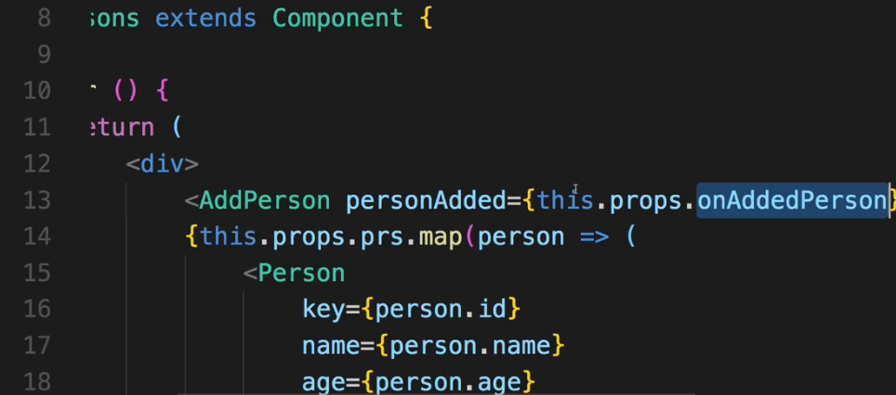  
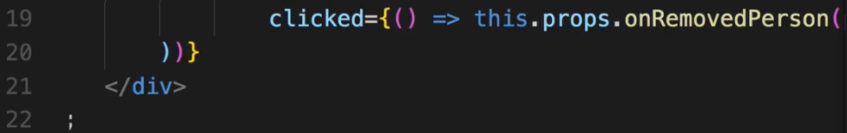 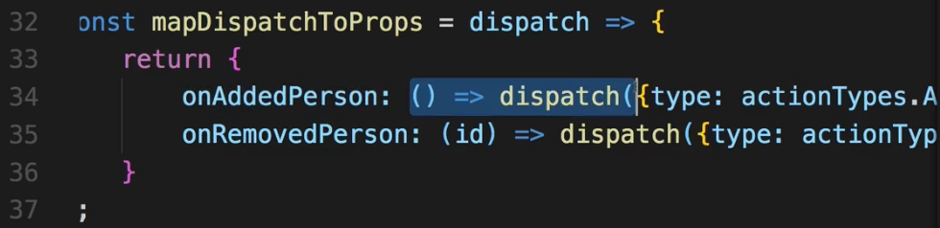  
=> So adding them:  
  
* Or we can just use 1 property like this:  
  
* And now with that we can go to our REDUCER and extract the value the user entered.  
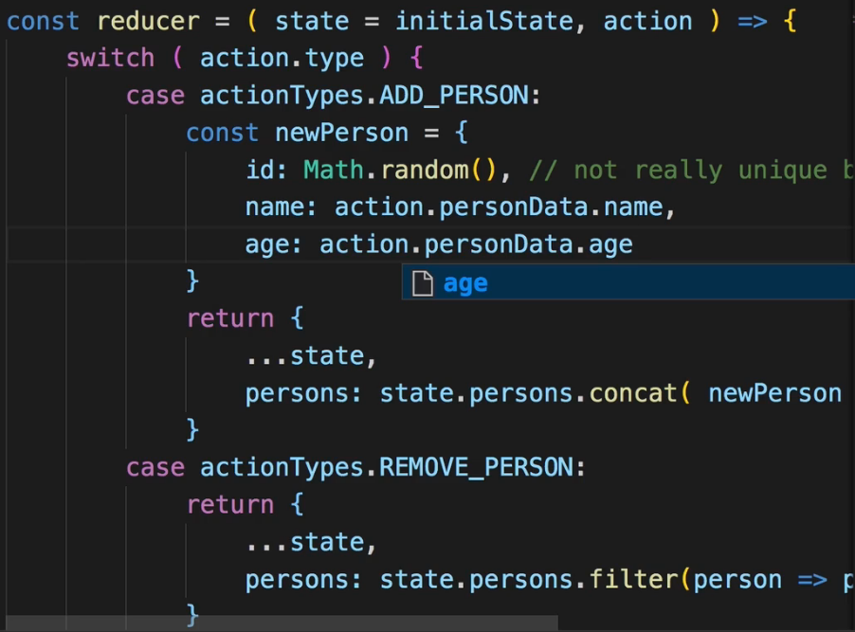  
* **In the local state let’s set the `age` to ‘’ instead of null or we get an error**.  
* Now we’re combining both Local UI State to handle the input and then still Redux to handle the created person which affects broader parts of our application.  
* **Using Local UI State for information that really is only relevant to this component and the Global State managed through Redux for information which is important for our entire application**.  
**Wrap Up**  
* You learned how Redux works in general, that you work with REDUCERs and ACTIONs, that you CONNECT your React containers to Redux to that STORE you created, that you can split up your REDUCERs into multiple REDUCERs with combineReducers, and that you should always manipulate your data immutably. Never directly mutate the STORE. You also see that we still work with containers and presentational components, we have the containers which are connected to Redux, where we get the state as props or the dispatch ACTIONS as props and that we can then still distribute our data down to other components. So this pattern hasn’t changed. But of course we can created as many containers as we need in the application to CONNECT them to our state and get the relevant slice of the state in each of our containers to then distribute it across all presentational components that this container knows.  
**Redux Docs**: <http://redux.js.org/>   
**Core Concepts**: <http://redux.js.org/docs/introduction/CoreConcepts.html>  
**Actions**: <http://redux.js.org/docs/basics/Actions.html>  
**Reducers**: <http://redux.js.org/docs/basics/Reducers.html>  
**Redux** **FAQs**: <http://redux.js.org/docs/FAQ.html>s